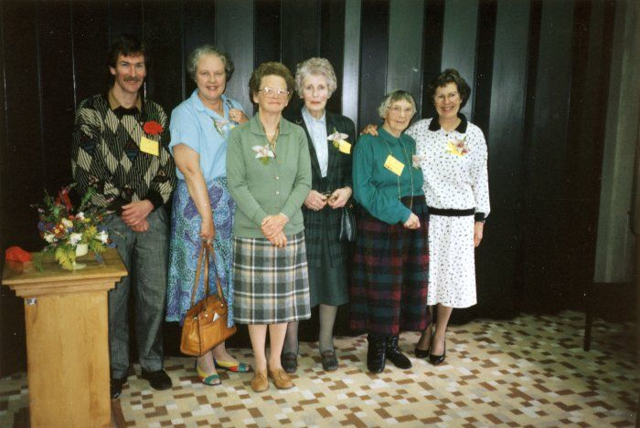

National Library of NZ, Reference Number: PAColl-3311-1-1
The Sunday speakers at the Wellington Free Kindergarten Graduates Association reunion, photographed on 8 October 1989 by an unknown photographer. From left: Simon Easton, Mary Purdy, Margaret Bennett, Joyce Barns, Marjorie Connell, Margaret Jones.

