A TEACHER’S PERSPECTIVE.

Have children benefited from the policy changes over
the last decade – What do teachers think?

Pat Irvine, Pat is the Co-ordinator of Professional Community Programmes,
Early Childhood, Dunedin College of Education
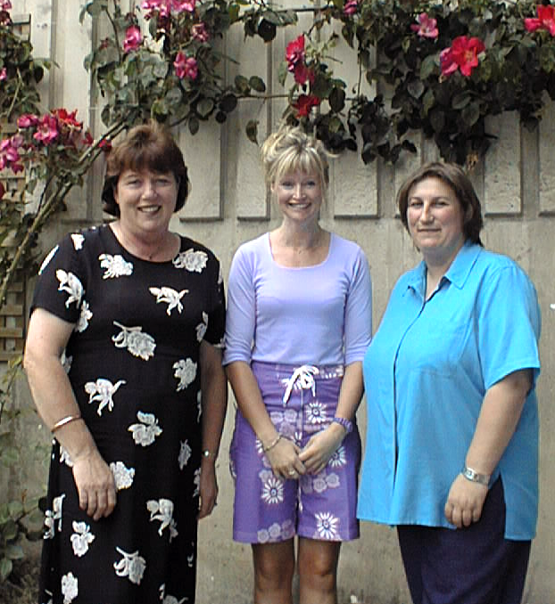

A very good question for early childhood teachers to reflect on now we are in a new century with a new government and the undoubted changes in policy direction this will bring.  The professional development team at Dunedin College of Education debated this very issue at some length one morning early last year. An interesting diversity of opinion emerged and it became evident that staff who had recently joined our team from teaching positions felt children had benefited very little from the changes. Those of us who had been involved in policy implementation and out of the field for some time felt there had been quite a lot of benefits for children.  This range of perspectives led us to undertake a study which set out to find out what teachers perspectives were and seek some answers to the following questions: What, if anything, had been improved by the introduction of new legislation and educational policy reforms? How had these reforms made a difference in their teaching practice and more importantly did they think children had benefited.  Since 1988, change has been a constant process for early childhood education centres in New Zealand. No less than six major policy documents have been implemented by early childhood teachers and services with each requiring extensive consultation, administration and documentation. Since all early childhood centres come under the same government | The Professional Development Team are from left to right Pat Irvine, Lee Blackie and Raewyn Penman  department in 1987, they have met regulations, written and negotiated two charter documents, survived several changes to funding policy and been reviewed and audited on all of the above. The only voluntary document in the last decade has been the Quality Journey.  There is little research into the links between government policy and its effectiveness in early childhood from a teacher perspective and much of policy rests on anecdotal rather than valid research evidence.  The sample of seventeen teachers in our study work in a range of early childhood centres in Otago and Southland, which include the major service providers childcare, kindergarten, playcentre, and home based family day care. Their individual length of teaching experience ranged from being at the very beginning of their careers to  Continued on page 3 | CONTENTS  Editorial 2  Letters to  The Editor 2  A Teachers  Perspective cont 3  Dads on the outside  Looking in 4  Conference 2001 6  Avocacy for  Kindergarten 7  A Discovery  Garden 8  Ed-u-talk 10  Board Talk 11  Insurance Corner 12



Editorial  EDITORIAL POLICY STATEMENT  The views expressed in this publication are those of its contributors. They do not necessarily represent the opinion of the Board of New Zealand Kindergartens Inc. (…likewise the grammer)  ADVERTISING RATES  Full page $150.00  Half page $75.00  Quarter page $40.00  Less than quarter page $30.00  Advertising deadline June issue 1 May 2001  Wanted  Your letters and thoughts  Have your say – write to the editor  Karen Boyes, Board Member  As kindergartens get back into the swing of a new year and the changing of the guard with new committees and association boards one can’t help but reflect on the past. We are in an environment of change in an evolving kindergarten service, with children and families leaving to move onto the next step in their education, new children and families starting. All involved develop and grow through this process. It always adds value to see how far we have come and the direction in which we head to move forward. In this fourth issue of Te Manu Hou we are looking at how Te Whariki has effected change in the curriculium that we deliver, while also reflecting on how we can meet the needs of the dads who have taken up the role of primary carer for children under five. We share the results from a vision to develop a kindergartens’ own little piece of native bush. Passion and commitment to the outcome developed something that the whole community can be very proud of and that is what kindergarten is all about. Merren Dobson outlines some of her aspirations in her new role with NZKI. As this will be my the last issue as Editor I would like to thank all of you for taking the time to read this publication and a special thanks for those who have contributed to our publication in its first year. | Letters to the Editor  Please forward your Letters to the Editor in the following format:  - 300 words or less  - Typed  - Name, address, telephone numbers, and signature of author must be included  - Anonymous letters will not be published  - The Editor reserves the right to publish or withhold letter  - No correspondence will be entered into  Late letters will not be published, unless issues raised remain relevant for a subsequent edition of the newsletter  Letter deadline June issue – 15 May 2001  Send letters to The Editor,  Te Manu Hou  Kindergarten Matters  PO Box 3058, Wellington. Fax 04 473 7991  E Mail nom@nzkindergarten.org.nz

The New Zealand Kindergartens National Board, on behalf of its members, would like to acknowledge the death of Peter Bussell, life member. Peter died after a lengthy illness on 5 February 2001.

Our sympathy goes out to his family and the other life members. Peter gave over 30 years’ service to the Kindergarten movement . A full tribute by Patricia Lockhart will feature in the June issue.

fifteen or more years in teaching. All the teachers were participating in a professional development programme. First the teachers completed a questionnaire, which asked them to rate how their work had been influenced by each of the changes over the past decade.  Continued from page 1  It is clear most of the teacher’s felt they had had little or no effect on improving the work they were doing. When we explored their views further in interviews, most teachers felt there had been some good aspect to the changes with some judged more beneficial than others.  The introduction of the early childhood curriculum Te Whāriki had the most favourable impact for all teachers and home based educators as demonstrated by responses in both the questionnaires and the interviews. All participants felt it had given them a framework to plan and implement programmes for children, and a shared discourse with colleagues in their centre. Although not apparent in the questionnaire the more expansive replies in the interviews showed the requirements in the charter statements to consult parents and community, were viewed more positively in the context of curriculum where teachers were involving parents in each child’s learning and development. Teachers with long service felt affirmed in their past practice which was now validated by new theoretical learning and a curriculum that articulated what they were doing with children in centre programmes.  The increase in paperwork was the least beneficial aspect of the educational reform process. Whilst acknowledging the need to be more accountable to government agencies, parents and community, most teachers lamented the time away from children and people contact that this now required. This pressure also included policies that they were positive about such as  Te Whāriki. The development of individual child profiles, with regular observations for planning, also added to this with the increased requirement for programme documentation involved. These factors have led the teachers to believe that all the requirements with the exception of Te Whāriki were not beneficial to children  Charter development was viewed more positively where effective professional guidance and support had been received. Centres who experienced staff turnover and a poor level of advice and support, | which necessitated repeated attempts at policy development, were less positive in their view of the benefits of the Desirable Objectives and Practices.  Teachers with long service tended to be more cynical about the changes and their implementation. However they did recognise the increase in status and professionalism that had resulted. Most felt their collegial relationships had been enhanced with the collaboration that now took place between parents, staff and community in planning programmes for children.  The answer to our original question of have children benefited would be yes through teachers perceptions of the value of Te Whāriki and their work with children. All teachers, no matter their length of service or levels of training or the service they work in, felt very positively about the impact of this unique New Zealand curriculum. It has affirmed them as teachers, validated their beliefs about how children learn and grow, and given them recognition and professional status. However, all other legislation and policies with the exception of the 1990 Education (Early Childhood Centre) Regulations have been perceived as unnecessary external factors which impact on what they enjoy doing most working with young children. Our final words come from a teacher in the study …  “The last 10 years have been hard work and heartache and exciting; overall worthwhile. It has pulled us into the 21st Century as a sector – we are much more professional. My own basic beliefs are the same now but I have far greater understanding and enhanced self esteem for the work I do – we now have visible, tangible evidence of our importance”.  This study was presented in a paper at the Early Childhood research Symposium University of Waikato, November 2000, and has been submitted for publication.
Dads on the outside looking in.  …Some thoughts on including Dads.  David Mitchell and Philip Chapman  David is a Senior Academic Staff Member at the Nelson Marlborough Institute of Technology.  Philip is an advocate in the area of Men’s Health and president of the New Zealand Father and Child society.  New Zealand families are changing and men are becoming more involved in child rearing. The reasons for this are varied. They include voluntary choices, changes in employment status, changes in family make-up from 2 parenting to custodial or non-custodial parenting, shift work and shared parenting arrangements. While much is being written and promoted at present about the importance of fathers in their children’s lives, not all the conditions to support this movement are ever in place at one time. For example, services that work with families, while welcoming more father involvement, are unsure of how to make their services more attractive or accessible to fathers.  The Public Health Unit of Nelson Marlborough Health Services recently commissioned a research study. The study aimed to gain information from Dads about their experiences of child and family services in the Nelson/Tasman region with the aim of enhancing their use of these services. As one Dad commented,  There‘s no use expecting a whole pile of people to change when they probably don’t know the difficulties that [Fathers] experience.  Nelson Dad  It should be noted that the term “child and family services” is defined generally and includes such areas as health, educational and social services (including early childhood services). The reason for this approach was that the study was to be the first stage of a continuing project with subsequent stages involving the research team working alongside specific service providers. It was considered that to identify specific organizations at this stage (perhaps critically) could jeopardise the | chances of future collaboration. It should also be noted that the term “Dad” is used rather than that of “father” as this was the preference of most of the men we asked.  The study involved a blend of quantitative and qualitative approaches to data gathering in order to give as broad an information base as possible. To this end, a survey as well as focus groups were used with the survey providing baseline information to be explored in more depth in focus groups. While information gained from this form of study should not be generalised to a wider population it may well prove useful to others in framing their understanding of their own environments. Certainly the process that was followed could be replicated.  The survey involved 150 questionnaires being distributed. The questionnaires were constructed to gather information including demographic details of the participants, frequency of use of child and family services, perceived usefulness of these services and barriers that were experienced in the use of services. Survey participants were also asked if they wished to be involved in one of three focus groups. The focus group participants were asked to respond to one question only - “What needs to happen to make child and family services more father friendly?”  In the survey the Dads indicated that with educational services, preschools were the most frequently used service and were also considered the most useful service in regard to meeting their needs. In contrast, the focus group discussion indicated that Dads often felt unsupported. The reasons for this contradiction seem complex. For example, many of the Dads when first presented with the survey were unable to comprehend and respond to the questions as was expected. In particular, many of the participants were unable to understand that the survey was about their experiences of services. They answered for their partners and children. It was as though they were quite unused to considering themselves as a valid recipient of support from child and family services. It seems that, when discussing the needs of Dads, discussion should begin at a more fundamental level than simply asking about needs.  When these Dads began to make a shift to that of considering their own needs, as was the case in the focus groups, many found this a new experience. During both the survey and the focus
groups, many Dads commented that they had never considered parenting issues from the  perspective of a Dad, having always considered parenting from the perspective of supporting the mother and child(ren). Thinking of their own needs as a parent, as well as how these needs could be supported, was a completely new experience for them.  While the study was broad in its focus there were certain themes evident that were pertinent to the pre-school area. These included,  a. The need for awareness raising by firstly exposing stereotypes and myths related to Dads and parenting. As one Dad noted,  Men are often portrayed [in the media] as the village idiot  Similarly, education about the real-life experiences of Dads. It was strongly felt that the experiences of Dads were largely untold. That there was ignorance in society about the realities of parenting for Dads. As one participant noted,  We need more input from fathers that have been there…done that. [Service providers] needed to address what the husband went through.  and another,  Possibly giving service providers more knowledge on what Dads want, to be able to respect the needs of Dads …[that is] recognise and appreciate Dads.  It was also felt important to promote positive images of Dads as being vitally interested and involved in the lives of their children. Several national and local initiatives were mentioned but the group lamented that these were few and were vastly outweighed by negative images, with a perceived lack of value of the role of Dads. As one participant noted,  Some decent education in terms of roles that fathers play and, perhaps more generally, the roles that men have to counter some of the culture of suspicion and fear that’s out there. Why are we [society] so suspicious? | Clearly the Dads believed that before services providers could begin to respond to and/or respect the needs of Dads they needed to be aware of the impact of stereotypes and myths as well as hear something of the real life experiences of this group of people. To achieve this goal it would seem initiatives would need to take place at a more fundamental level, for example in the area of staff education.  b. Positive initiatives in involving Dads. During the preschool years the Dads described a strong presence in the lives of their partners and children. They talked about being frequently there (or thereabouts), they were there to be of help, but generally didn’t know how to be of help. In addition they found it difficult to communicate their sense of isolation and difference, feeling as though services were unable to assist them in this area. It was consistently voiced that, because of this continuing sense of isolation and difference their presence diminished as the children aged. One suggestion was that, because of the difficulties Dads experienced in being involved during these times, their energy and enthusiasm waned. However the important point was that they described themselves as more accessible to service providers at this time.  There’s some point in every Dad’s life - they’re open, before the door gets closed. That’s the time to put other Dad’s [and not professionals] alongside them. The key is knowing what their needs are and what the entry points are.  Nelson Dad  The problems inherent in getting alongside Dads in areas where they have historically been absent are complex. However, it does seem that service providers and Dads are keen to work together. It is the pathways to achieving this that appear difficult to identify and follow. We believe that managing this tension is often beyond the resources of service providers and that some form of facilitation or advocacy is required to change an environment which is constraining all involved. To this end, service providers should identify key people, preferably Dads, who are able to work with them to facilitate change. This was a key area of discussion in the focus groups as well.
What seems quite remarkable is that far from being the silent and distant people who find considerable difficulty in expressing emotion, the Dads in the study shared their experiences openly and enthusiastically. They talked with considerable interest and passion for their parenting role and they shared stories of vulnerability and pain. They also demonstrated an ability to work together in developing new insights into their world as well as creating solutions to complex problems. Providing increased opportunities for these abilities to be realised within the context of the family seems timely as we meet the challenges that the 21st century holds for our society. | Footnote. While originally asked to provide advice about practical ways in which Kindergartens could increase the involvement of Dads in their areas we have deliberately kept our discussion quite general. We believe this is consistent with the views of the Dads in the study who were insistent that before meaningful change could occur there needed to be a fundamental shift in the manner in which service providers and Dads themselves viewed the nature of parenting and in particular the specific needs of men within this role.  A copy of the research study can be obtained from  Gaye Berry, Health Promotion Advisor  Nelson Marlborough Health Ltd  Private Bag NELSON  The authors can also be contacted through this address.

New Zealand Kindergartens Inc. - Conference 2001

KINDERGARTEN – A GREAT CHOICE!
Marlborough Centre, Blenheim, 22nd, 23rd, 24th June 2001

The NZK Inc 2001 conference marks the 75th Jubilee of the national organisation of New Zealand Kindergartens. The theme for conference this year reflects the reality that parents do have a range of choices of early childhood education options for their children and that KINDERGARTEN IS A GREAT CHOICE! The Marlborough Kindergarten Association is proud to be hosting the national conference in Blenheim in 2001.  The conference programme reflects a mix of the political and the practical. The keynote speaker, Dr Sarah Farquhar is sure to challenge our thinking when she presents a paper entitled “Policy Challenges for the Kindergarten Service”. Dr Farquhar is the Co-ordinator NZ Early Childhood Research Network, is a trained Kindergarten teacher, holds a Higher Diploma of Education and obtained her Ph.D through Otago University. She is also a mother to young children.  The issue of Leadership often poses a problem for community based organisations. Professor Robin McConnell, Head of the School of Sport at Unitec will be speaking at the conference. Robin has taught a range of Leadership courses through postgraduate levels and his doctoral area was in elite team leadership. He spent 3 - 4 years with the All Blacks observing coaching and captaincy at that level. The roots of his work however, lie firmly in education, as his background is that of a teacher. | The Father & Child Trust seek to help men take a more positive, pro-active role in their children’s’ lives. Much work has been done to identify how this can best be achieved with positive outcomes for children, men and women. Phillip Chapman will be addressing the conference and Mike Wignall and Jim Yates will be leading a workshop for the Father & Child Trust.  There is a return to workshops this year. Delegates will be able to attend two workshops of their choice. Topics for the workshops vary greatly from marketing to the Internet to procedures, regulations and ensuring our service is inclusive to men. This year this will also be a workshop designed specifically for the senior teachers.  Conference is an important time for establishing networks throughout the organisation. It is a great time to catch up with old friends and meet the new faces of our member organisations. There will be plenty of opportunity for open discussion time during the conference as well as social events, which provide a chance to truly get to know each other better.  So, escape to the sun, the wine, talk the talk and Love Marlborough! After Conference, stay awhile. If you wish, we will be happy to organise an extended stay for you. Contact the Conference Convenor, Fiona Braid, at f.g.braid@xtra.co.nz or Conference Chairperson, Sally Kennedy, at sal.kennedy@xtra.co.nz
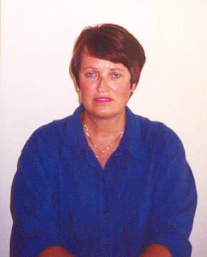  Hocus pocus advert  Advocacy for Kindergarten  By Merren Dobson  NZKI National Advocate  The Board of New Zealand Kindergartens has much pleasure in welcoming Merren Dobson to the organisation in a new role of NZKI National Advocate. Merren has worked extensively in the early childhood sector with the last 3 years as National Senior Advisor of Early Childhood Education for the Ministry of Education. We look forward immensely to working with Merren and utilising her vast knowledge and skill.  Talofa lava, Kia orana, Malo e lelei, Fakaalofa lahi atu, Taloha ni, Ni sa bula, Kia ora, Greetings  Thank you for the opportunity to greet you and provide you with these initial comments. Like many of you I have spent many years immersed in, or perhaps, engulfed by early childhood education in some capacity or other. Over the past 28 years I have been an early childhood education student, practitioner, manager and bureaucrat and now I find myself a part-time student again. I recommend the cocktail of experiences. | In the very new and challenging role of NZKI National Advocate I will support and promote the efforts of individuals and groups working to provide affordable, accessible and high quality early childhood education programmes for young children in kindergartens. I am committed to promoting understanding and respect of the Treaty of Waitangi, biculturalism and other cultures in Aotearoa/New Zealand.  I will also promote the preservation and maintenance of cultural values and first language of the younger generations of Pacific children in Aotearoa/New Zealand.  As the National Advocate for NZKI I expect to:  - seek opportunities to promote the value of New Zealand kindergartens’ high quality early childhood education programmes, both nationally and internationally;  - seek opportunities for NZKI teachers and management to present papers at national and international forums.  - seek and provide opportunities to raise public awareness and improve understanding of the benefits of good quality early childhood education programmes through education, promotion and persuasion;  - pursue national issues with appropriate agencies, for resolution; and  - celebrate and draw on associations’ diversity while building consensus on critical issues;  - build and enhance positive networks, both within the NZKI organisation and with other education agencies/organisations, and  - develop, in collaboration with others, innovative solutions for problem situations.  The journey of striving for excellence continues. Let us commit to contributing to NZKI as a dynamic early childhood education organisation that is visionary and focused for the future.  I look forward to our new connections.

A Discovery Garden  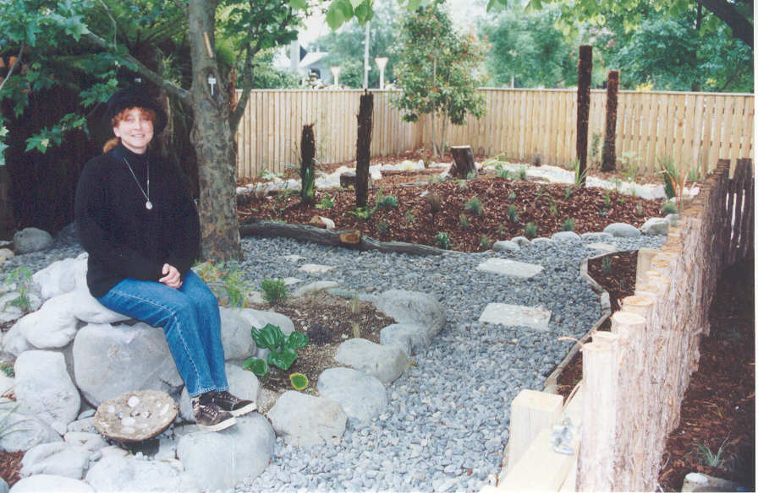  Pat Jepsen, Teacher  York Street Kindergarten, Masterton  As early childhood educators we are always seeking new and innovative ways to stimulate and educate the young mind. Therefore when I started teaching kindergarten in the Wairarapa, I would always plan an excursion into the local forest to introduce the children to the wonders of the bush, it never failed to amaze me how many children had never visited this valuable area with their parents. I started to develop a desire to somehow introduce the children to the bush in a safe and secure environment. Why not create our own native bush at the kindergarten!  The kindergarten I worked in had a really neat team, and when I suggested to the other two teachers, Jenny Braaskma (head) and Judy Clark, my idea to bring the bush into town, they were enthusiastic for the idea. I was doing an ASTU paper through Wellington College of Education, and an opportune assignment came along enabling me to develop plans and do research to back up my ideas for the Discovery Garden as I needed to have approval from my Association to establish the garden.  Charmaigne Watkins, a parent at the kindergarten, heard of the idea and at once became an enthusiastic campaigner for the project, it was she who enticed a professional Landscape Designer and Consultant (Richard Ashcroft from Carterton) to come and see us. He talked with the children and teachers and also became enthusiastic, he gave us his time, his expertise, his labour for free (he refused to be paid) and said “This way I can give something back to the community”!  We set up a meeting with Richard and the children, we talked about developing a garden just for them, one that would look like native bush, but we needed to know what they would like in it. We had many responses, someone wanted a cave with glowbugs, lizards, tuis, a waterfall, pigeons, wetas, sharks, electric eels and lots lots more. Richard returned a week later with the plans.  The parents at York Street Kindergarten looked over the Garden design with growing enthusiasm. Charmaigne tackled the hardest job of all, asking | for free resources from the larger community, and to her credit they gave freely. Then Jenny, Charmaigne, our Senior Teacher Sue Patrick and myself held meetings to finalise the plans and begin the establishment of the garden. Sue provided an excellent fence design for the garden using manuka poles for battens which gave the garden a rustic feeling. It had been decided that the area needed to be protected as the many plants would need nurturing till established. We felt that because the garden contains native New Zealand plants their historic value also needed to be protected. This was an important part in teaching our children the need to understand how to respect our environment.  Rangimarie Rose Pere in her article “Te Wheke: Whaia te Maramatanga me te Aroha”, states that her parents’ generation instructed the children in practical matters, such as the harnessing, conserving and gathering of crops and the need to know and respect the land were all part of the children’s learning – for example, seasons, plant and animal rhythms, family and community gatherings. This pattern of learning was necessary and important.  She goes on to talk about “Mauri” (life principles, ethos)…  “If great importance and support is given to the mauri of each individual in the family, in time the individual, the family, will appreciate the mauri in other people, the mauri of trees, the mauri of rivers, the mauri of the sea and the mauir of mountains. The traditional courtyards and the mountains of New Zealand have heard and felt the mauri of the language as spoken by our Maori forebears before the intrusion of any other. The mauri of the language is very important to the family unit and the way it can withstand negative influences. Respect for the natural environment and conservation are important aspects of the whole”.
It is very important to the teachers at York Street that we teach our children to respect the environment. Our Maori families and whanau are very important to us and it is important to show them that we understand the need for respecting our environment.  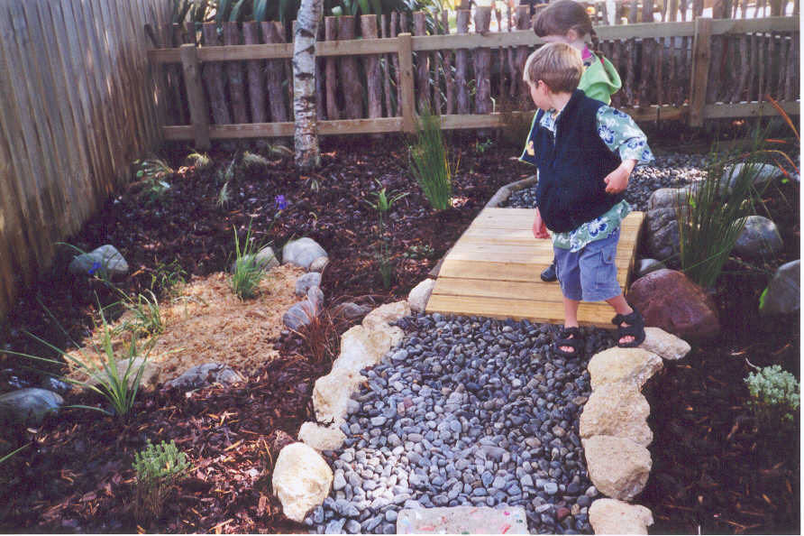  With the help of our dedicated parents, their children, and labour from the horticulture students from our local polytechnic, we planted about 200 native plants and established our own piece of native bush on site.  The students of York Street Kindergarten have filled their days with wonder and excitement as the garden has grown around them. They are developing a respect for their native heritage and will learn to look after their garden and preserve its continued growth.  What I value most about creating and establishing a Discovery Garden, is the wealth of learning that will come out of this area. Through interactions teachers will be able to offer rich and rewarding experiences, nurturing growth in all areas of our curriculum.  Young children are busy people, they like to touch, pat, dig, poke, shake, listen, smell, pour and play around with whatever is new and interesting in their environment. Close observation of young children suggests that it is through this busyness that they learn about the world around them.  Research and theory strongly support this observation. (Piaget 1927; Kamli and Devries 1978; Bredekamp 1987; Rivkin in press).  Because young children learn primarily through their senses and through manipulation, they are excellent candidates for nature education experiences. The elements of the natural world offer the raw materials to manipulate, and best practitioners in early childhood education promote the hands-on approach to learning. The pairing of young children and nature, then, seems to be natural and desirable. (Wilson, R A 1995 Nature and Young Children; A Natural Connection). | We can never underestimate the value of gardens in our kindergartens. We all have a vegetable or flower plot providing excellent and stimulating learning experiences where children learn about planting, fertilising, watering, weeding, pest control, harvesting and composting. Isn’t it important to reach our children now and teach them “skills for life”!  Our children when they graduate from kindergarten take with them knowledge not only of how to tend a garden, but make concrete pavers and tuffa pots, (which are found in the garden). They have developed skills working with and alongside their peers, and developed a “love for learning”. They have also taken on board the need for conservation, protecting our heritage and being more aware of the environment they live in.  The garden is a place of peace and tranquillity, of wonder and new experiences, a place to retreat to when the hurly burly of kindergarten life gets to be too much, a place for everyone to relax, unwind and contemplate in.  Ruth Wilson sums it up nicely. The focus of Early Childhood Education is on the development of the whole child, we do not limit ourselves to the cognitive or academic domain. With this focus, nature education has invaluable resources to offer. Experiences in the out of doors tend to be rich in opportunities for nurturing growth in all of the developmental domains. She goes on to talk about Aesthetic development. Aesthetics means being sensitive to beauty but by experiencing it in a variety of forms, the delight of snow on evergreen boughs, the smell of the earth after a spring rain, the sound of a bird singing overhead, and the feel of kittens’ fur or the moss on the side of a tree. For the young child, the world of nature is an especially appropriate avenue for fostering an appreciation of beauty.

Your Contributions are welcomed
Next copy deadline for articles
1st May 2001

  Ed-u-talk  News - views from  NZ Kindergarten Senior Teachers  An Opinion  Management and Leadership in Early Childhood/Kindergartens  Eirlys Toothill  Teaching Services Manager  Gisborne Kindergarten Association  A leader in the education sector must inspire a clear vision for their organisation and communicate it to other staff and parents, seeking their input to encourage strong ownership of that ‘vision’. In early childhood education centres the ‘leader’ must do all things. They must both lead and manage the centre to enable the centre to function effectively. Dalli,C. quotes Rodd (1995) as saying “…teachers are not trained to be effective leaders: the effective manager may not be a leader but the effective leader does have to be an effective manager – if only to ensure they have enough time to devote to leadership issues.”  Therefore to be an effective leader a person needs to be an effective manager, but management skills are not the same as leadership skills. How many of our teachers are proficient managers but lack leadership ability? The style of ‘flat’ leadership seems to work best in most early childhood centres. This is about teachers working in a team sharing all work and responsibilities.  So what is the difference between leadership and management?  Leadership is about people, about enthusing people. Listening to them, empowering them, supporting and challenging them. It is complex, dynamic and strongly person centered.  Management tends to be about administrative ‘paper shuffling’ systems, day to day running and planning, generally keeping things ticking over.  Most teachers are fine at leading children but what about the other partner in a children’s early years: Parents? Do teachers have the skills to support, lead and empower parents? I suggest yes, that |  | most do. Dalli again quotes Rodd (1994) as saying “…The professional role of the early childhood teacher has primarily focussed on the direct interactions with children, and to a lessor degree parents”. Early childhood teachers must be encouraged to further develop their leadership skills. This will then enable them to work more in a partnership with adults while still working with children.  There is a constant need to change to meet the needs of stakeholders and withstand a changeable environment. Most early childhood centres encourage shared ownership and I believe that Kindergarten Teachers are working hard to further strengthen their ties with parents and whanau. Kindergartens have to respond to the new challenges, e.g.: increasing numbers of working parents. We must provide a service that really suits our stakeholders. Are we really able to do this without changing the whole philosophy of Kindergarten? Or will we have to become more childcare focused? How can we achieve stronger partnership ties? Only through constant Communication and Consultation with our stakeholders and more lobbying of the Government will we be able to achieve this.  By constantly reflecting on our past practices and learning from them we will have a better understanding of what may lie ahead. Only then will we be able to respond proactively to enforced change rather than being reactive, wasting time and energy on what used to be.  It is therefore important to encourage teachers to develop skills in both professional and personal areas, most especially in leadership roles. With the constant need to respond to change in the education environment we must be prepared to embrace the challenges that are taking us into the new century. With the main one being meeting the needs of our ‘clients’.  Selected references:  - Rodd,J (revised 1998) Leadership in Early Childhood. The pathway to Professionalism. Sydney: Allen and Urwin.  - Dalli,C (1995) Management and Leadership Skills in Early Childhood. Keynote Address: TRCC Course 28th August-1st September.  P2-3.

 BoardTalk
News - views from National Board Members

Kindergarten – A Great Choice!
By Sally Kennedy
Board Member

Less than four months to go and life is about to get more hectic than ever before. “Why?” I ask myself many times a day, “Why did I think conference in Marlborough would be a good idea?” The answer to that is as complex in many ways as it is simple. Kindergarten was, and still is, a great choice for my children. Conference is a chance to get together with people from all over New Zealand, exchange ideas, learn something new and celebrate our organisation – KINDERGARTEN!  In my naïve LBK (Life Before Kids) days, I never gave much thought to what it takes to ensure that we, the general population, get to adulthood as well-rounded, socially acceptable and useful members of society. Therefore, it was with great bravado and our eyes firmly shut, that we entered our LAP (Life As Parents) days. I had not anticipated the tidal wave of advice that would descend on us as soon as the announcement of a new addition to our family was made. On one occasion I felt that I had temporarily left this planet – The Utero University!!! Apparently this involves strapping a device to your growing belly and playing music and tapes espousing the theory of relativity to the as yet unborn child. I have to say that this was all too far out on a limb for me. I thought babies were babies who grew into toddlers, children, aliens (teenagers) and then adults. Was I wrong to assume this would just happen? I resolved to follow my own instincts but somewhere a tiny seed had been sown – just what did babies need to be babies, grow into toddlers, children, aliens and then adulthood?  Education, simple enough – they need education! I was happy again. I knew what my children needed. Then came the inevitable questions, what, how and when? The answer to these questions is invariably going to be different depending on the many facets that make up your life. For me it was the strong desire to have my children experience the carefree joy of being a child whilst learning about the world | around them. I started to think about my own childhood. By my own admission I am a “reader”. I love reading. As a child I secretly read with a torch in bed. What is the point to this story – well I didn’t learn to read until I was seven. It wasn’t that I had a problem learning to read, I didn’t start school until I was 6 ½. It was what we did. I didn’t even know the alphabet when I started school and I could most certainly not spell or write my name. None of this held me back at all. My point is that I had been given crucial pre-reading and pre-writing skills in an environment that I loved and had great fun in. One of my greatest loves is a jigsaw puzzle. I might not have known my alphabet but I could whip through a 500-piece jigsaw before I started school. I could also play cards. My grandparents were great card players. Before I learnt how to play I was allowed to deal the cards. “Count them carefully, Sally”. Another skill! To me I was just having fun and that is what I wanted for my children.  I was thrilled to find that Kindergarten gave me that choice for my children. My children could have fun, play and socialise to their hearts content all the while gaining the pre-requisite skills to enable formal learning to take place at the appropriate time. I have often heard my peers lamenting that their 3 yr-old is not being taught to sit at a desk and read and write. It intrigues and worries me. Often the parents are highly skilled, educated and successful adults. When asked at what age they learned to read, most would say between 5 and 7. Has it ever held them back? NO! The putting together of letters to form words is the final piece of the puzzle. The ability to recognise shape and form are the first pieces.  So, the reason for taking on a task as huge as conference organisation has everything to do with the belief that Kindergarten IS a great choice. It also gives me the chance to put something back into an organisation that has given my children the skills in preparation for their next big journey – School.

INSURANCE CORNER - An update from your brokers
Olwyn Griffin  Wilkinson Insurance Brokers  We have been receiving the usual claims for vandalism and theft, and one or two parts of the country were unlucky enough to be hit with serious storm water and hail damage. It is always valuable in minimising losses over these extended holiday periods, if someone checks the premises immediately following significant weather problems such as these. Wet carpets and contents only become worse if they left in that condition, not to mention the pressure that goes on everyone to get all items repaired or replaced quickly to avoid delaying opening of the centre after the holidays.  Unfortunately we have some bad news to report in respect to premiums. The government has increased Fire Service Levies again this year, affecting all renewals from 1 March 2001. Fire Service levies are charged on the Indemnity Value (IV) of the buildings and contents. Once again we would recommend that you consider the accuracy of this figure on your insurance schedule, and if necessary arrange for a valuer to produce a valuation detailing both Replacement values and Indemnity values. | The Indemnity value (representing current market value) is only on your policy for purposes of charging Fire Service Levies. It does not change the fact that the insurer will pay full replacement value for all items being claimed on.  Fire Service Levies are charged at a rate per $100 of Indemnity Value. The chart below shows how these have increased over the last couple of years:  - 0.45c  - 0.62c  - 0.73c  Those of you who have had dealings with Gary Brown over the last 7 years will be sorry to hear that he has chosen Christmas time to resign from Wilkinson Insurance Brokers, move out of the broking market and back into the insurance company market. The goods news is that he is now working for HIH Insurance who are the full providers of the cover to the Early Childhood sector through the Wilkinson scheme, and has assumed responsibility for the running of the Central region.  Any queries will still be handled by Olwyn Griffin, Cindy Elrick or Malcolm Milne.



Wilkinson Insurance Brokers (Wgton) Ltd
INCORPORATING bg brokers

Ansett House, 67-71 Boulcott St, Wellington, New Zealand
P O Box 11641, Wellington. Telephone: 64-4-499 0557. Facsimile: 64-4-499 0558

with HIH Casualty and General Insurance Co Ltd

Proud sponsors of the first year of Te Manu Hou➔Kindergarten Matters

and New Zealand Kindergartens’ new banner.

Free phone 0800 966 666

Olwyn Griffin olwyn@wibco.co.nz Cindy Elrick cindy@wibco.co.nz

